Patterned Paper Control - Monkeys

Zeynep Civelek

July 08, 2020

## Exploring data

The structure of the data is shown below with all the variable names and levels of measurement.

## 'data.frame': 448 obs. of 11 variables:  
## $ id : Factor w/ 14 levels "Alba","Bear",..: 11 11 11 11 11 11 11 11 11 11 ...  
## $ sex : Factor w/ 2 levels "f","m": 2 2 2 2 2 2 2 2 2 2 ...  
## $ age : int 8 8 8 8 8 8 8 8 8 8 ...  
## $ order : Factor w/ 2 levels "foodfirst","stickfirst": 1 1 1 1 1 1 1 1 1 1 ...  
## $ boxtype : Factor w/ 2 levels "blue","pink": 1 1 1 1 1 1 1 1 1 1 ...  
## $ phase : Factor w/ 2 levels "pattern-test",..: 1 1 1 1 1 1 1 1 1 1 ...  
## $ sessionno: int 1 1 1 1 1 1 1 1 2 2 ...  
## $ trialno : int 1 2 3 4 5 6 7 8 9 10 ...  
## $ correct : int 1 1 1 1 1 1 1 1 0 1 ...  
## $ trialtype: Factor w/ 2 levels "food","stick": 1 1 1 1 1 1 1 1 1 1 ...  
## $ phase2 : Factor w/ 2 levels "1","2": 1 1 1 1 1 1 1 1 1 1 ...

Exploring the warm-up 1 (the cups are initially empty/not covered and after the hiding event the baited cup is covered with patterned paper and the empty cup is covered with white paper) and warm-up 2 phases (the cups are initially covered with white paper and after the hiding event, the baited cup is covered with patterned paper).

**In warm-up 1, monkeys received up to 11 sessions to reach criterion and in warm-up 2, up to 2 sessions (or they'd receive up to 10 sessions). The minimum number of sessions to reach criterion was 2 (14/16 correct)**

## Histograms for Warm-up 1 and Warm-up 2 Phases

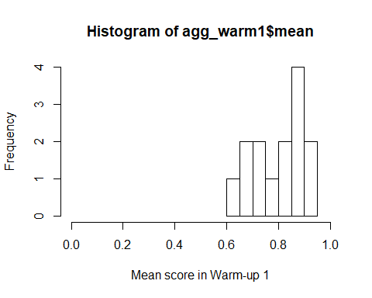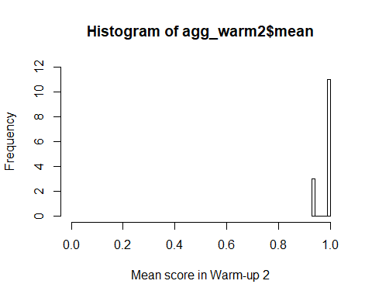

**The data shows that after the initial warm up phase, the monkeys very quickly learnt to find the reward in the patterned cup.**

I then aggregated the trial-by-trial data to create one score per monkey for Test and Transfer phases so I can see the distribution of scores.

## Histograms for Test and Transfer Phases and the overall score

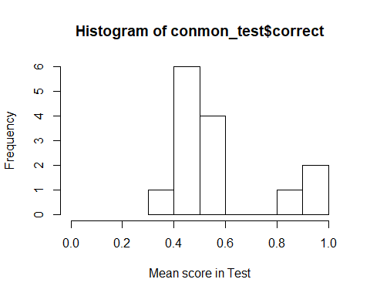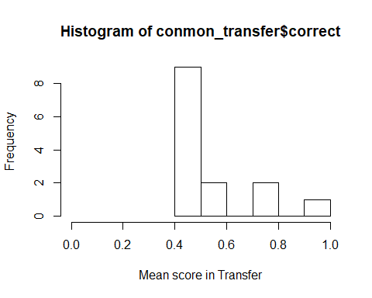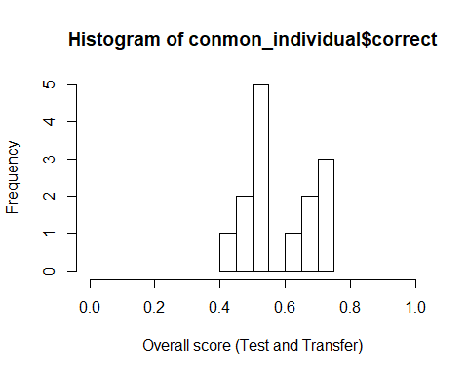

## Preparation of the data for running the GLMM

* Scaling age and trial number
* Coding categorical variables (trial type, sex, phase) as dummy variables
* Centering the slopes.

## Full model

contr<-glmerControl(optimizer="bobyqa", optCtrl=list(maxfun=10000000))  
full=glmer(correct ~ trialtype*phase+z.trialno+z.age+sex+(1|id)+(0+z.trialno+phase.transfer.c+trialtype.food.c|id),data=conmon1, family=binomial, control=contr)

The full model does not include box type (the location of the blue/pink box) as a random effect anymore due to convergence issues. There is the singular fit warning here and throughout though.

## Model assumptions

#### Distribution of random effects

I don’t know what happened to the first two plots here.

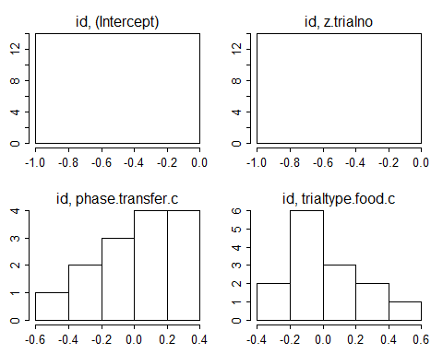

#### Model stability

I could not calculate model stability, but I’ll look into this.

#### Multicollinearity

## trialtype phase z.trialno z.age sex   
## 1.021 1.021 1.000 1.003 1.003

## Null model

null=glmer(correct~ z.trialno + (1|id)+(0+z.trialno+phase.transfer.c+trialtype.food.c|id),data=conmon1, family=binomial, control=contr)

Trialno is added to the null model.

## Full and Null comparison

## Data: conmon1  
## Models:  
## null: correct ~ z.trialno + (1 | id) + (0 + z.trialno + phase.transfer.c +   
## null: trialtype.food.c | id)  
## full: correct ~ trialtype * phase + z.trialno + z.age + sex + (1 |   
## full: id) + (0 + z.trialno + phase.transfer.c + trialtype.food.c |   
## full: id)  
## npar AIC BIC logLik deviance Chisq Df Pr(>Chisq)   
## null 9 617.32 654.26 -299.66 599.32   
## full 14 615.65 673.12 -293.82 587.65 11.67 5 0.04 *  
## ---  
## Signif. codes: 0 '***' 0.001 '**' 0.01 '*' 0.05 '.' 0.1 ' ' 1

## Model output

#### Coefficients

## Estimate Std. Error z value Pr(>|z|)  
## (Intercept) -0.268 0.293 -0.915 0.360  
## trialtypefood 0.884 0.354 2.496 0.013  
## phasepattern-transfer 0.146 0.336 0.436 0.663  
## z.trialno -0.100 0.099 -1.006 0.315  
## z.age 0.235 0.110 2.135 0.033  
## sexm 0.343 0.225 1.525 0.127  
## trialtypefood:phasepattern-transfer -0.449 0.481 -0.935 0.350

#### Individual predictor: Likelihood tests

## Single term deletions  
##   
## Model:  
## correct ~ trialtype * phase + z.trialno + z.age + sex + (1 |   
## id) + (0 + z.trialno + phase.transfer.c + trialtype.food.c |   
## id)  
## npar AIC LRT Pr(Chi)   
## <none> 615.65   
## z.trialno 1 614.66 1.014 0.314   
## z.age 1 617.70 4.051 0.044 *  
## sex 1 615.72 2.068 0.150   
## trialtype:phase 1 614.53 0.881 0.348   
## ---  
## Signif. codes: 0 '***' 0.001 '**' 0.01 '*' 0.05 '.' 0.1 ' ' 1

**The null and full models are significantly different from each other. But the interaction term is not significant. I will remove this next to see if it improves the model.**

## Reduced model without the interaction

## Full model 2

full2=glmer(correct ~ trialtype+phase+z.trialno+z.age+sex+(1|id)+(0+z.trialno+phase.transfer.c+trialtype.food.c|id),data=conmon1, family=binomial, control=contr)  
summary(full2)

## Generalized linear mixed model fit by maximum likelihood (Laplace  
## Approximation) [glmerMod]  
## Family: binomial ( logit )  
## Formula: correct ~ trialtype + phase + z.trialno + z.age + sex + (1 |   
## id) + (0 + z.trialno + phase.transfer.c + trialtype.food.c | id)  
## Data: conmon1  
## Control: contr  
##   
## AIC BIC logLik deviance df.resid   
## 614.5 667.9 -294.3 588.5 435   
##   
## Scaled residuals:   
## Min 1Q Median 3Q Max   
## -1.7781 -1.0601 0.5867 0.8700 1.2194   
##   
## Random effects:  
## Groups Name Variance Std.Dev. Corr   
## id (Intercept) 0.0000 0.0000   
## id.1 z.trialno 0.0000 0.0000   
## phase.transfer.c 0.1806 0.4250 NaN   
## trialtype.food.c 0.1461 0.3822 NaN -0.73  
## Number of obs: 448, groups: id, 14  
##   
## Fixed effects:  
## Estimate Std. Error z value Pr(>|z|)   
## (Intercept) -0.09487 0.22831 -0.416 0.67774   
## trialtypefood 0.65350 0.24868 2.628 0.00859 **  
## phasepattern-transfer -0.06273 0.24805 -0.253 0.80036   
## z.trialno -0.09941 0.09894 -1.005 0.31501   
## z.age 0.19268 0.10077 1.912 0.05586 .   
## sexm 0.25938 0.20543 1.263 0.20671   
## ---  
## Signif. codes: 0 '***' 0.001 '**' 0.01 '*' 0.05 '.' 0.1 ' ' 1  
##   
## Correlation of Fixed Effects:  
## (Intr) trltyp phspt- z.trln z.age   
## trialtypefd -0.461   
## phspttrn-tr -0.463 -0.132   
## z.trialno 0.002 -0.013 0.001   
## z.age 0.029 0.037 0.025 -0.009   
## sexm -0.572 0.026 -0.010 -0.006 -0.071  
## convergence code: 0  
## boundary (singular) fit: see ?isSingular

I get the following warning: convergence code: 0, boundary (singular) fit: see ?isSingular.

## Null model 2

null2<-glmer(correct~z.trialno+(1|id)+(0+z.trialno+phase.transfer.c+trialtype.food.c|id),data=conmon1, family=binomial, control=contr)

## Full and null model (2) comparion

## Data: conmon1  
## Models:  
## null2: correct ~ z.trialno + (1 | id) + (0 + z.trialno + phase.transfer.c +   
## null2: trialtype.food.c | id)  
## full2: correct ~ trialtype + phase + z.trialno + z.age + sex + (1 |   
## full2: id) + (0 + z.trialno + phase.transfer.c + trialtype.food.c |   
## full2: id)  
## npar AIC BIC logLik deviance Chisq Df Pr(>Chisq)   
## null2 9 617.32 654.26 -299.66 599.32   
## full2 13 614.53 667.89 -294.27 588.53 10.79 4 0.029 *  
## ---  
## Signif. codes: 0 '***' 0.001 '**' 0.01 '*' 0.05 '.' 0.1 ' ' 1

## Model output

#### Coefficients

## Estimate Std. Error z value Pr(>|z|)  
## (Intercept) -0.095 0.228 -0.416 0.678  
## trialtypefood 0.654 0.249 2.628 0.009  
## phasepattern-transfer -0.063 0.248 -0.253 0.800  
## z.trialno -0.099 0.099 -1.005 0.315  
## z.age 0.193 0.101 1.912 0.056  
## sexm 0.259 0.205 1.263 0.207

#### Individual predictors : Likelihood ratio tests

## Single term deletions  
##   
## Model:  
## correct ~ trialtype + phase + z.trialno + z.age + sex + (1 |   
## id) + (0 + z.trialno + phase.transfer.c + trialtype.food.c |   
## id)  
## npar AIC LRT Pr(Chi)   
## <none> 614.53   
## trialtype 1 618.34 5.807 0.016 *  
## phase 1 612.60 0.064 0.801   
## z.trialno 1 613.54 1.012 0.315   
## z.age 1 615.71 3.175 0.075 .  
## sex 1 613.85 1.319 0.251   
## ---  
## Signif. codes: 0 '***' 0.001 '**' 0.01 '*' 0.05 '.' 0.1 ' ' 1

**The model without the interaction is significantly different from the null model too. There is no effect of phase in this case, but trial type has a significant effect on performance. There is a trend for age to have an effect on performance as well but I'm not going to further explore this as we had no apriori expectations about age for monkeys.**

## Plotting the findings

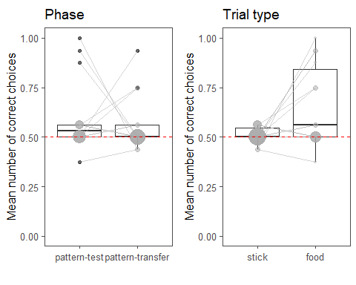

## Test against chance

#### Test and transfer phase

testphase <-conmon1%>%  
 filter(phase == "pattern-test")  
testchance <- glmer(correct ~ 1 + (z.trialno | id), data= testphase, family=binomial)  
summary(testchance)

## Generalized linear mixed model fit by maximum likelihood (Laplace  
## Approximation) [glmerMod]  
## Family: binomial ( logit )  
## Formula: correct ~ 1 + (z.trialno | id)  
## Data: testphase  
##   
## AIC BIC logLik deviance df.resid   
## 301.9 315.5 -146.9 293.9 220   
##   
## Scaled residuals:   
## Min 1Q Median 3Q Max   
## -2.0861 -1.0837 0.4815 0.8500 1.0934   
##   
## Random effects:  
## Groups Name Variance Std.Dev. Corr   
## id (Intercept) 4.917e-01 0.701189   
## z.trialno 6.807e-05 0.008251 -1.00  
## Number of obs: 224, groups: id, 14  
##   
## Fixed effects:  
## Estimate Std. Error z value Pr(>|z|)   
## (Intercept) 0.4775 0.2396 1.993 0.0463 *  
## ---  
## Signif. codes: 0 '***' 0.001 '**' 0.01 '*' 0.05 '.' 0.1 ' ' 1  
## convergence code: 0  
## boundary (singular) fit: see ?isSingular

transferphase <-conmon1%>%  
 filter(phase == "pattern-transfer")  
transferchance <- glmer(correct ~ 1 + (z.trialno | id), data= transferphase, family=binomial)  
summary(transferchance)

## Generalized linear mixed model fit by maximum likelihood (Laplace  
## Approximation) [glmerMod]  
## Family: binomial ( logit )  
## Formula: correct ~ 1 + (z.trialno | id)  
## Data: transferphase  
##   
## AIC BIC logLik deviance df.resid   
## 314.1 327.7 -153.0 306.1 220   
##   
## Scaled residuals:   
## Min 1Q Median 3Q Max   
## -1.3394 -1.1117 0.7744 0.8975 0.9297   
##   
## Random effects:  
## Groups Name Variance Std.Dev. Corr   
## id (Intercept) 0.0704518 0.2654   
## z.trialno 0.0002495 0.0158 -1.00  
## Number of obs: 224, groups: id, 14  
##   
## Fixed effects:  
## Estimate Std. Error z value Pr(>|z|)   
## (Intercept) 0.2718 0.1558 1.744 0.0811 .  
## ---  
## Signif. codes: 0 '***' 0.001 '**' 0.01 '*' 0.05 '.' 0.1 ' ' 1  
## convergence code: 0  
## boundary (singular) fit: see ?isSingular

**This is a change now and is interesting!** Performance at Test seems to be above chance **(barely)** and Transfer is not **(barely?)**. The thing is most of the monkeys performed at chance in Test, but there are 3 who did really well and I suspect they are bringing the mean up (**Q:** Is the intercept a good test in such cases?). Moreover, these monkeys got the food-stick trials in Test. When they switched in Transfer, performance dropped. Conversely the ones who did well in Transfer were the ones who got food-stick trials. It is incredible that phase and trial type interaction wasn't significant in the first model... This is a very tricky finding. I think it shows that monkeys can perform well in this task (both patterned and ripped) when the memory demands are low and they do not need to engage in any reasoning at all. And I think this jeopardizes the positive findings from the ripped foil a little but doesn't explain it fully as they performed much better in that task than here. Looking forward to discussing these!

#### Trial type

## Generalized linear mixed model fit by maximum likelihood (Laplace  
## Approximation) [glmerMod]  
## Family: binomial ( logit )  
## Formula: correct ~ 1 + (z.trialno | id)  
## Data: sticktrials  
##   
## AIC BIC logLik deviance df.resid   
## 318.5 332.1 -155.2 310.5 220   
##   
## Scaled residuals:   
## Min 1Q Median 3Q Max   
## -1.0180 -1.0180 0.9823 0.9823 0.9823   
##   
## Random effects:  
## Groups Name Variance Std.Dev. Corr  
## id (Intercept) 0.000e+00 0.000e+00   
## z.trialno 1.368e-16 1.169e-08 NaN  
## Number of obs: 224, groups: id, 14  
##   
## Fixed effects:  
## Estimate Std. Error z value Pr(>|z|)  
## (Intercept) 0.03572 0.13365 0.267 0.789  
## convergence code: 0  
## boundary (singular) fit: see ?isSingular

## Generalized linear mixed model fit by maximum likelihood (Laplace  
## Approximation) [glmerMod]  
## Family: binomial ( logit )  
## Formula: correct ~ 1 + (z.trialno | id)  
## Data: foodtrials  
##   
## AIC BIC logLik deviance df.resid   
## 281.1 294.8 -136.6 273.1 220   
##   
## Scaled residuals:   
## Min 1Q Median 3Q Max   
## -2.5390 -1.0702 0.4094 0.8234 1.1486   
##   
## Random effects:  
## Groups Name Variance Std.Dev. Corr   
## id (Intercept) 0.848467 0.92112   
## z.trialno 0.004617 0.06795 -1.00  
## Number of obs: 224, groups: id, 14  
##   
## Fixed effects:  
## Estimate Std. Error z value Pr(>|z|)   
## (Intercept) 0.7942 0.2968 2.675 0.00746 **  
## ---  
## Signif. codes: 0 '***' 0.001 '**' 0.01 '*' 0.05 '.' 0.1 ' ' 1  
## convergence code: 0  
## boundary (singular) fit: see ?isSingular

Performance is not different from chance level in stick-food trials and it is above chance in food-stick trials as it is also clearly seen in the plot.

## Correcting the p-values for the post-hoc tests using Hochberg correction (in the order: test, transfer, stick-food, food-stick)

pvalues <- c(0.0463, 0.0811, 0.789, 0.00746)  
p.adjust(pvalues, method="hochberg")

## [1] 0.13890 0.16220 0.78900 0.02984

**OK, maybe I spoke too soon about the Test, Transfer phase results above- the corrected p-values show that these are not significant, only the performance in food-stick trials is above chance. But we may decide to discuss the performance of those 5 monkeys (3 in test and 2 in transfer) who did really well in this task regardless of p-values, right?**

#### How about the first trial performance in Transfer phase: Is performance above chance?

conmon_1st_trial <- conmon1 %>%  
 filter(phase=="pattern-transfer" & sessionno=="1", trialno=="1")  
#I am fitting a glm with binomial error structure for the first trial transfer phase analysis and not a mixed model given that it only includes one data point per subject.  
firsttrialchance <- glm(correct ~ 1, data= conmon_1st_trial, family=binomial)  
summary(firsttrialchance)

##   
## Call:  
## glm(formula = correct ~ 1, family = binomial, data = conmon_1st_trial)  
##   
## Deviance Residuals:   
## Min 1Q Median 3Q Max   
## -0.940 -0.940 -0.940 1.435 1.435   
##   
## Coefficients:  
## Estimate Std. Error z value Pr(>|z|)  
## (Intercept) -0.5878 0.5578 -1.054 0.292  
##   
## (Dispersion parameter for binomial family taken to be 1)  
##   
## Null deviance: 18.249 on 13 degrees of freedom  
## Residual deviance: 18.249 on 13 degrees of freedom  
## AIC: 20.249  
##   
## Number of Fisher Scoring iterations: 4

**No, performance in the first trial of transfer does not differ from chance level.**